Chapter 10, Solution 35.
j2 
-j4 A
10 
-j5 
8 
-j3 
4 
+
−
20 V
I₂
I₃
I₁
1 

Consider the circuit shown below.

For the supermesh,
(1)

Also,
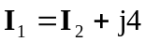 (2)

For mesh 3,
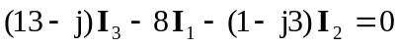 (3)

Substituting (2) into (1),
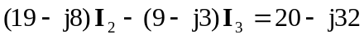 (4)

Substituting (2) into (3),
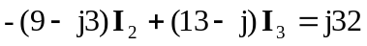 (5)

From (4) and (5),
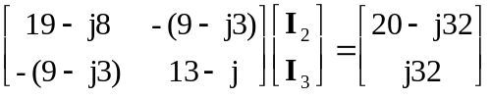

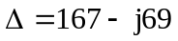, 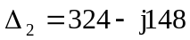

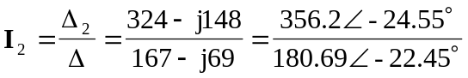

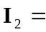 1.971–2.1 A

